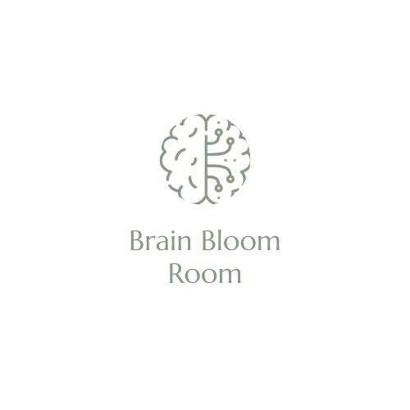Brain Bloom Room ‘Replenish’ Programmes

**Client/Parent/Caregiver Consent Form**

Client’s Name_____________________________

Address__________________________________________________

Date of birth_______/_______/_______

Age(If under 18)_________________ School Year____________

**Emergency Contact Details:**

Full Name of Primary Contact Person _______________________

Relationship to Client___________________

Phone Number: Mobile/Work________________________

Email Address:_______________________________

**Medical Information:**

Name of Client’s GP___________________________

Medical Center Name and Phone Number

__________________________________________________________________

Does the client suffer from any medical condition that would prevent him/her from partaking in an exercise based movement programme? **Y/N**

***Please note, If yes then they will not be able to be part of the programme***

It is always advisable to consult your physician before starting any exercise programme.

**I give permission** for me/my child to take part in the movement based ‘Replenish’ exercise programme provided by the **Brain Bloom Room** **Y/N**

**I give permission** for medical attention to be sought in case of emergency **Y/N**

**I understand** that the movement programmes require at-home exercises. Commitment to programme requirements is necessary for greater success. Results may vary from individual to individual **Y/N**

Signature:_____________________________ (Client or Caregiver) Delete as necessary

Date:____/____/____